**Practical No. 1**

1. **Preparing Raspberry Pi: Hardware preparation and**

**Installation**

**Step 1: Go to www.raspberry.com**

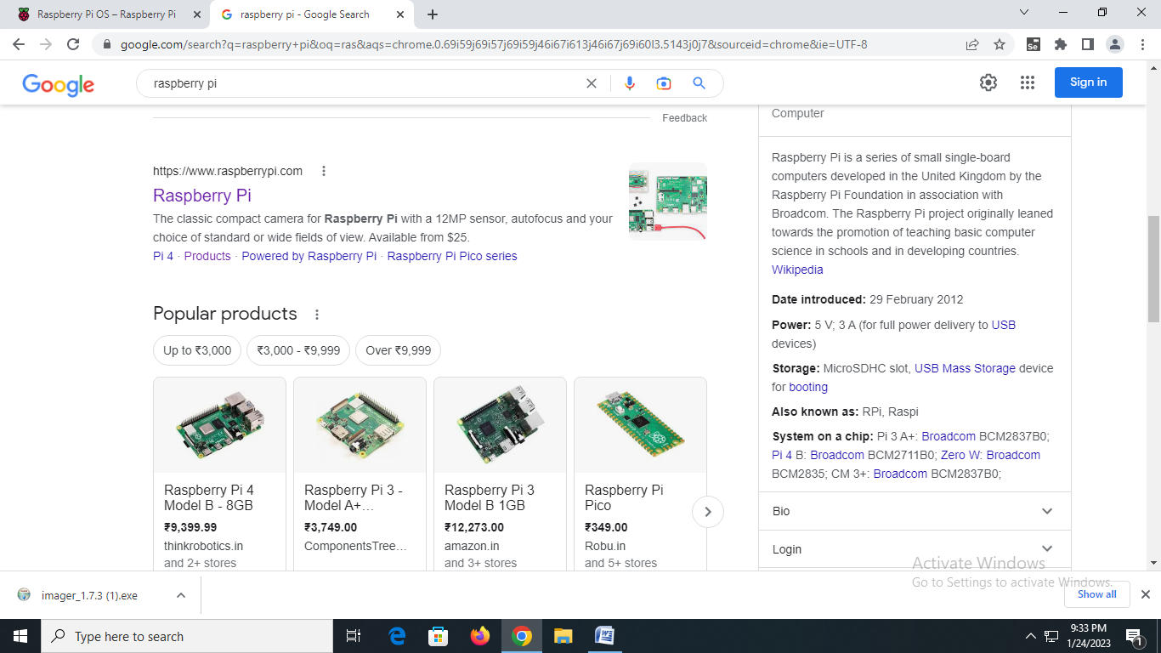

**Step 2: Download Raspberry Pi Imager for Windows**

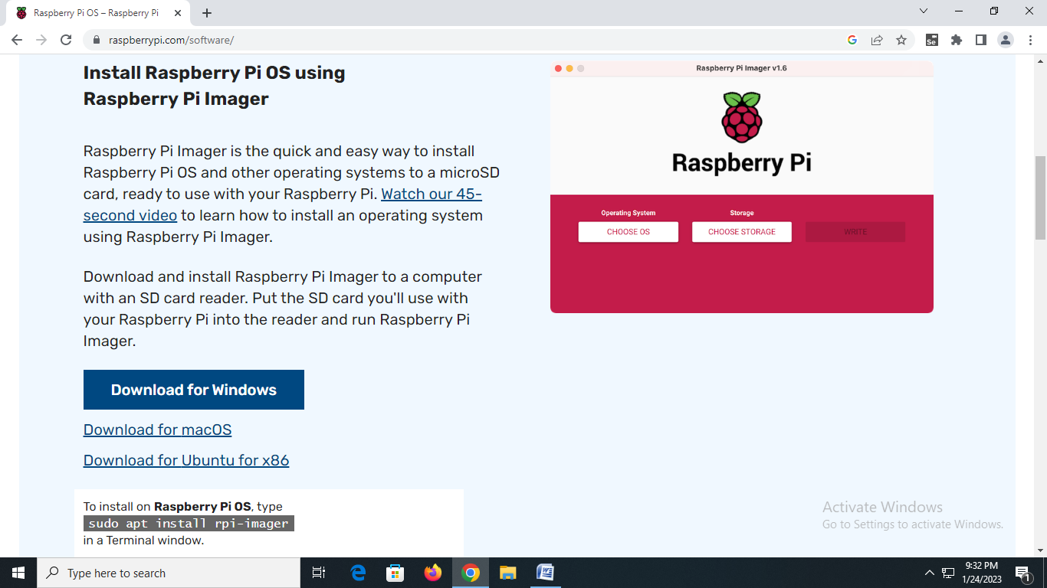

**Step 3: Open Setup and Install Raspberry Pi Imager**

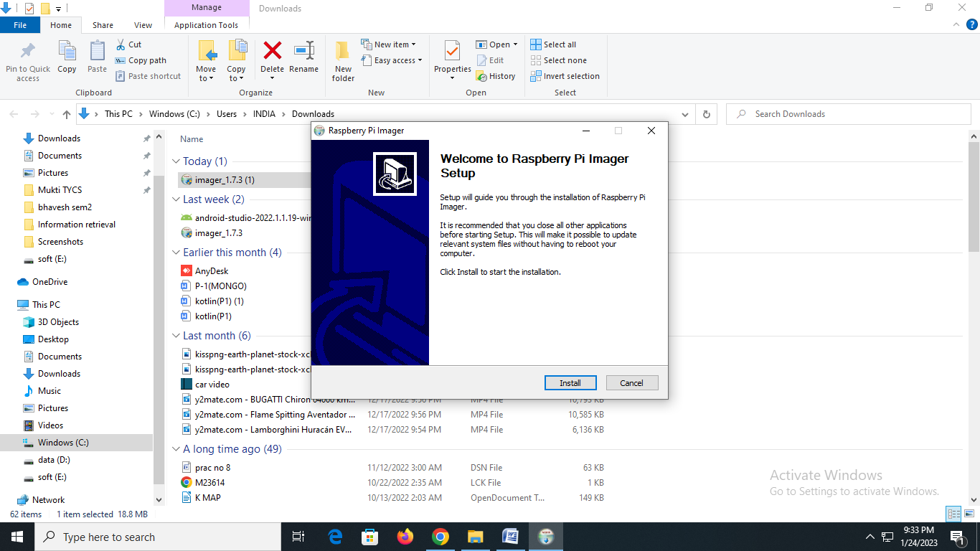

**Step 4: Open Raspberry Pi Imager**

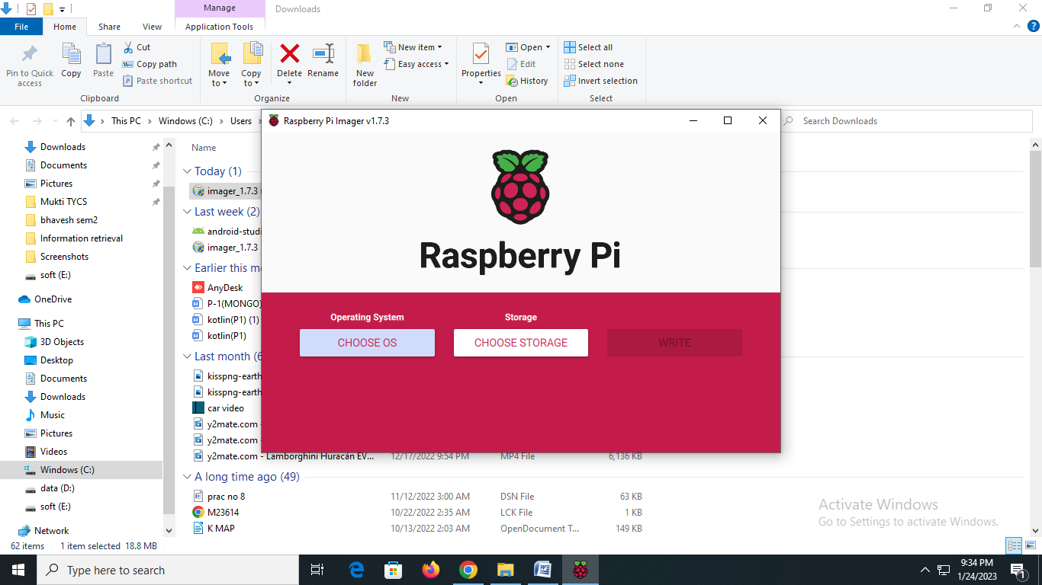

**Step 5: Click on Choose OS and Choose ‘Raspberry Pi OS (32-**

**bit)’**

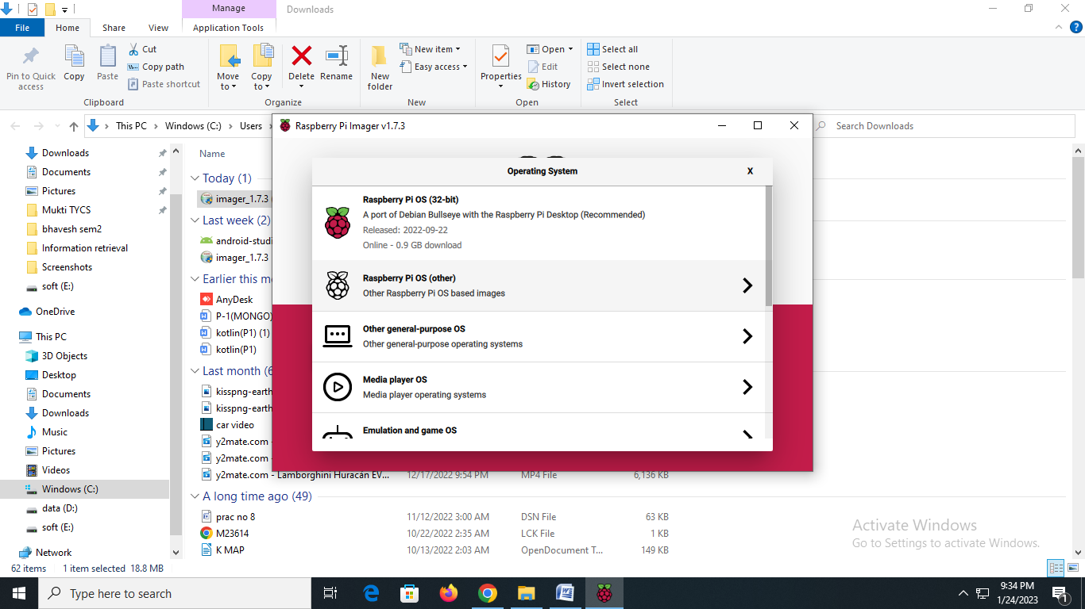

**Step 6: Choose Storage**

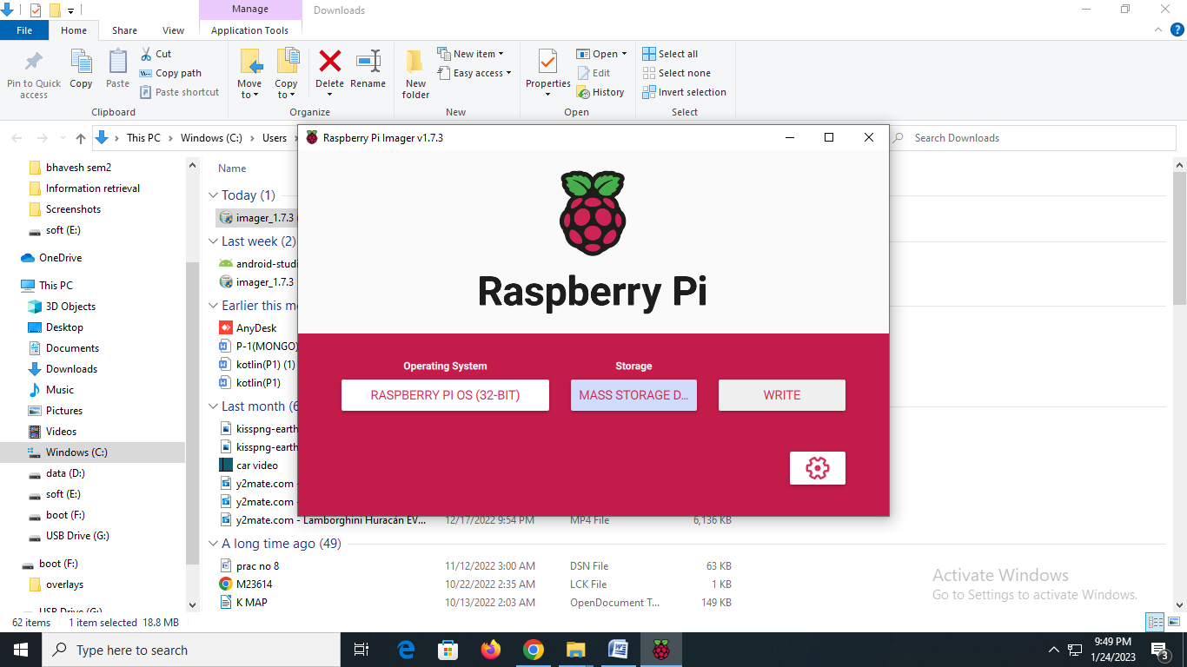

**Step 7: Click ‘Write’**

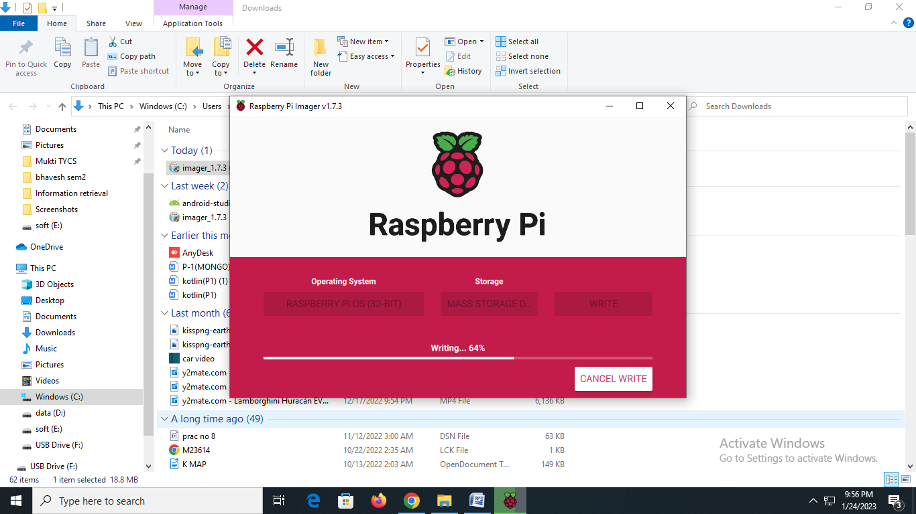

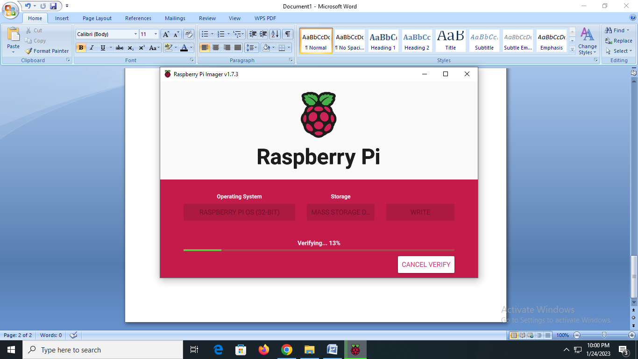

**Step 8: Installation Completed**

